**ALEXANDER BERG**

**QA Engineer**

Junior Quality Assurance engineer with IT knowledge. Finished online university QA program. IT geek for 12 years. Looking forward to joining a company and use my creativity and experience to improve the overall quality of a product or service. All my skills, code and contacts on my personal web-site.

ineer with IT knowledge. Finished

. IT geek for 12 years. Looking

and use my creativity and experience of a product or service. All my skills, onal web-site.

**Alpha tester**

*Ubisofi, Wargaming*

Tested games like "World of warships", "For Honor", "Anno" in closed alpha

**Sales Assistant**

*OOO "Palmira"* programs.

Engaged in sales of digital equipment, smartphones, laptops and SIM cards

**Low current systems engineer assistant**

*OOO "Bors"*

Was engaged in the installation of low-current security and fire safety systems

**Technical Support**

*OOO "Teletrade"*

Assisting clients with complex technical issues requiring in-depth problem solving

**QA engineer**

*Netology Online university*

Studied Software development, software testing, Java, C#, CI/CD, tests automation.

**Municipal & government managment**

*Herzen State University*

**Meteorologist**

*Russian State Hydrometeorological University*

CONTACT INFORMATION

**Email**

[alexandr.berg92@gmail.com](mailto:alexandr.berg92@gmail.com)

**Address**

Saint Petersburg, Russia

EXPERIENCE

*2018 - 2020* 

**Alpha tester**

*Ubisofi, Wargaming*

Tested games like "World of warships", "For Honor", "Anno" in closed alpha programs.

**Phone**

+79062452865

**Date of birth**

Jun 22, 1992

**Link**

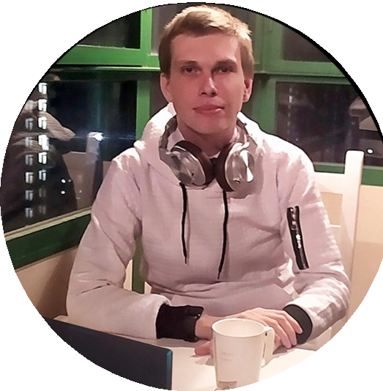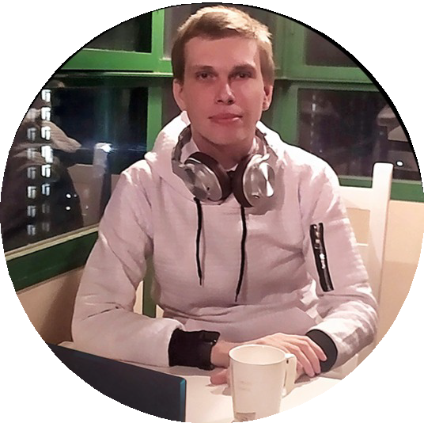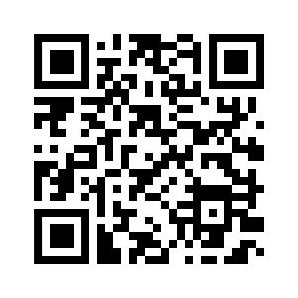

Saint Petersburg

*2016 - 2018*

Saint Petersburg

*2014 - 2015*

Saint Petersburg

*2013 - 2014*

EDUCATION

Russia

*2020 - 2021*

Saint Petersburg

*2012 - 2013*

Saint Petersburg

*2010 - 2011*

* **Sales Assistant**

*OOO "Palmira"*

Engaged in sales of digital equipment, smartphones, laptops and SIM cards

* **Low current systems engineer assistant**

*OOO "Bors"*

Was engaged in the installation of low-current security and fire safety systems

* **Technical Support**

*OOO "Teletrade"*

Assisting clients with complex technical issues requiring in-depth problem solving

* **QA engineer**

*Netology Online university*

Studied Software development, software testing, Java, C#, CI/CD, tests automation.

* **Municipal & government managment**

*Herzen State University*

* **Meteorologist**

*Russian State Hydrometeorological University*

alexander-berg.github.io

SKILLS

* Working knowledge of Web Automation
* Excellent analytical skills
* Experienced in bug reporting and finding errors
* Multiple IT skills
* Covid-19 certificate

LANGUAGES

**English**

Advanced

**Russian**

Native